**Project Design Phase-II**

**Data Flow Diagram & User Stories**

| Date | 15 October 2022 |
| --- | --- |
| Team ID | PNT2022TMID32596 |
| Project Name | IoT based Safety Gadget for child safety monitoring & Notification |
| Maximum Marks | 4 Marks |

**Data Flow Diagrams:**

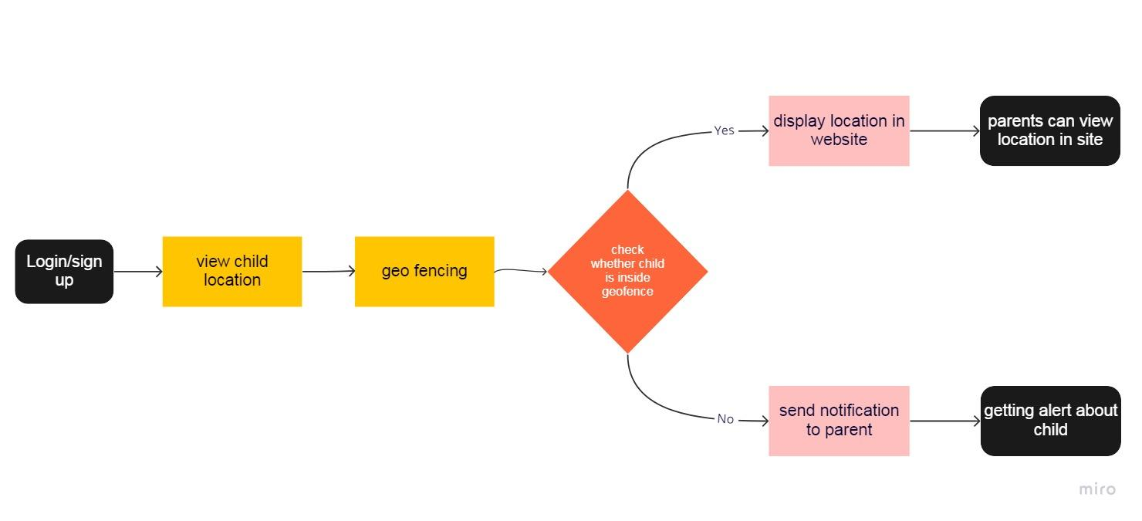

**User Stories**

| **User Type** | **Functional Requirement (Epic)** | **User Story Number** | **User Story / Task** | **Acceptance criteria** | **Priority** | **Release** |
| --- | --- | --- | --- | --- | --- | --- |
| Customer | login/sign up | USN-1 | User can register for the application by entering my email, password, and confirming my password. | I can access my account / dashboard | High | Sprint-1 |
| Customer | Tracking | USN-2 | User can view location in the website | I can view location | High | Sprint-2 |
| Customer | Geo fence | USN-3 | User can make geo fence for the child | Geo fence created | High | Sprint-3 |
| Customer | Notification | USN-4 | If the child went out from the fence the user can get notification | Notification received | High | Sprint-4 |